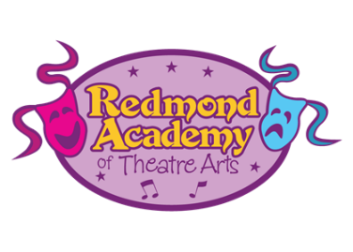
Redmond Academy of Theatre Arts
Application for full or partial program scholarship
Please complete and email this form to Alison Brandon board secretary, at ratasecretary@gmail.com with a cc’ to alison_brandon@icloud.com, or return a hard copy to the business desk at Studio B.

Student Name
Parent/guardian name
Address
Parent phone number
Parent email
Class or show for which the student needs a scholarship
Does your student need a full or half scholarship?
Please describe the reason your student needs a scholarship
Thank you for applying for a scholarship at the Redmond Academy of Theatre Arts. Casting decisions are not dependent on scholarship status. You will be informed of the board’s decision as soon as possible. If you have any questions please email Alison Brandon at ratasecretary@gmail.om and alison_brandon@icloud.com

